Edgar Pena

ICSI 410

May 10, 2019

Deliverables

1. The purpose of this project is simple. To provide a service for a Library computer that interconnects various systems such as employees, books, and borrowers. This system would be used on a computer at a small library at the help desk by a customer, or computer behind the main desk by any of the faculty in the Library. I hope to achieve an ecosystem of information within the Library that leads this Library to run as efficiently as possible.

The customers of this Library want the experience of signing out a book to be as quick as possible and thanks to this system, they only need to grab the book, sign in to there customer account, and write the book id. 3 easy steps lead to a happy customer. For the employee. This DBSM also acts as an efficient way to sign in and clock there hours. This is important because many employees are volunteers who wish to clock their hours. Finally its important for the administrator to keep track the book stock. This system adds an efficient way to remove lost or stolen books from the DB, as well as adding books that have recently been purchased.

All in all you can see that this system will be very useful in running a Library

1. The database is called LibraryManage. Within this DB lies three tables Books, Borrowers, and Employees. Within the Books table lies 5 columns.

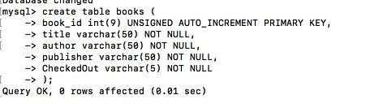

book_id is the primary key of the books table. It takes in the integer type and will auto-increment by one with each new addition. Title takes in a string of 50 characters, as does author and publisher. CheckedOut takes in a string of 5 but it will only take in 1 character, Y or N.

The Borrowers Table holds 5 columns,

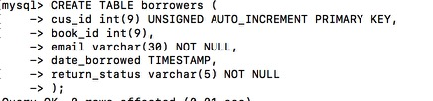

Cus_id is the primary key for borrowers and is also auto incremented by , the book id of the currently borrowed book is also a column, if the person has returned a book and has not borrowed another one then this data value would be null. The email and return status would contain strings, while the date borrowed column contains the timestamp which is in the format yyyy-mm-dd hh-mm-ss, this can be useful in creating various systems for past due books and distributing fines.

The employees table is a useful way to manage faculty, the table contains 5 columns.

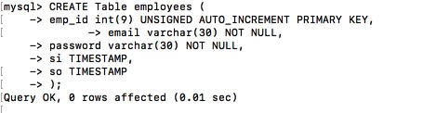

Emp_id contains the auto-incremented primary key, while the email and password columns contain strings. The si and so column contain timestamps in order to document a workers hours. How these tables interact can be better seen by an E-R diagram

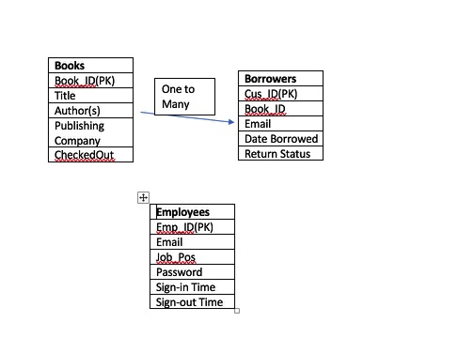

1. For implementation, I used MySql for the terminal on mac for the creation of the databases, for the application of the program, I used Java. The tool that I in order to implement and write Java was eclipse.
2. When the user first runs the app, he will be asked a question

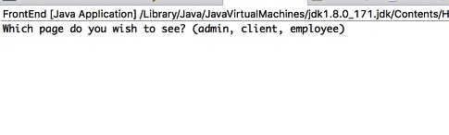

This allows the user to decide which aspect of the system they wish to interact with. Here is what each page shows you.

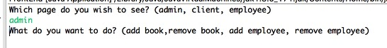

This page and these functions are accessed using this block of code.

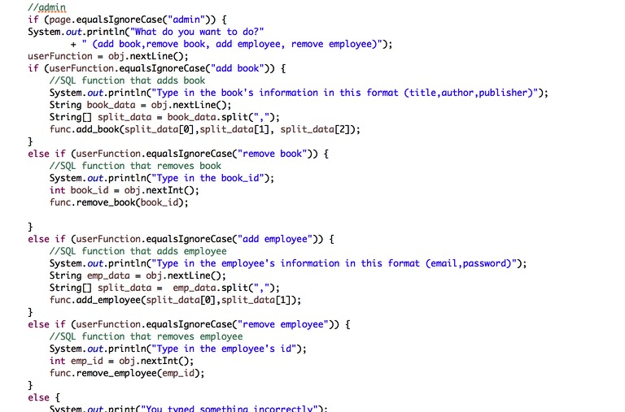

The client side and employee side are made similiarly.

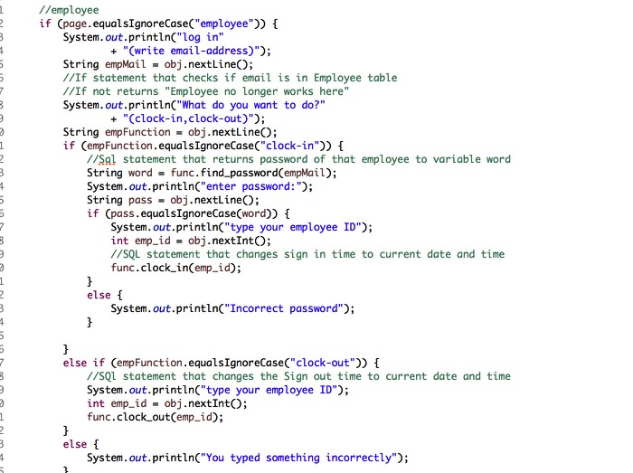

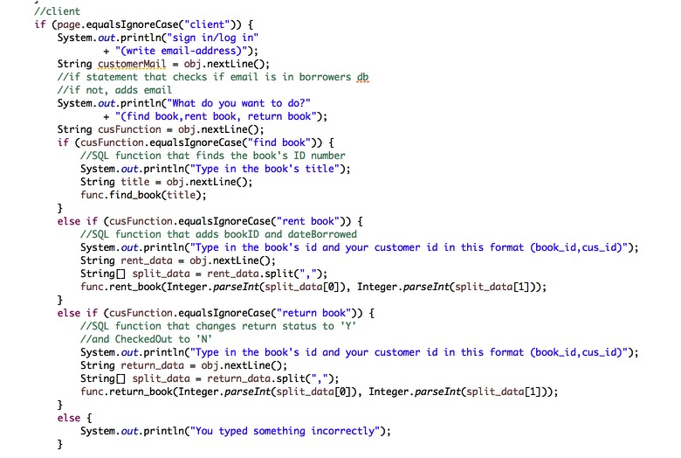

All of the function basically consist of creating an object that connects the java application to the SQL Database LibraryManage in this way.

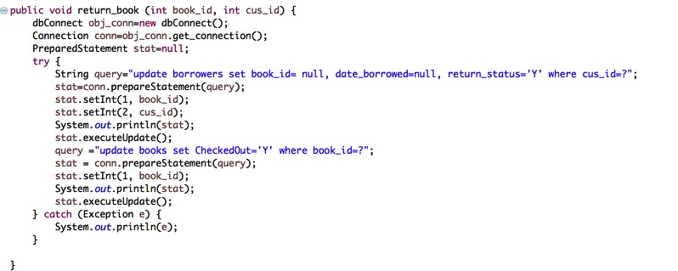

The query is prepared as an SQL statement and then executed. We can see this in action on the results page.

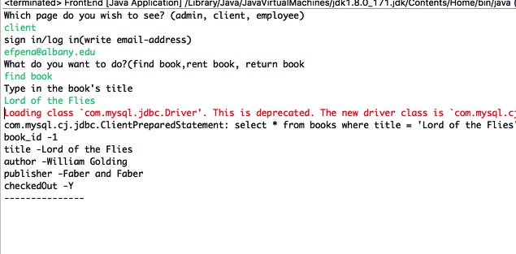

As you can see the function access the SQL Database and retrieves the information from the table books.

1. All in all, the project goals were meet. I created an application that access a Library Management database, connected clients, employees and the administrator to an easy to use program that keeps all information in the LibraryManage system up to date. All the test cases for each of the functions passed. There are still certain aspects of the code that can be improved such as when a client wants to get rid of their account. This is something that can be added in subsequent updates to the program. After all, there really is no such thing as a finished program.